RESOLUTION NO.__________

RE: CERTIFICATE OF APPROPRIATENESS UNDER THE
PROVISIONS OF THE ACT OF THE PENNSYLVANIA
LEGISLATURE 1961, JUNE 13, P.L. 282 (53
SECTION 8004) AND BETHLEHEM ORDINANCE NO.
3952 AS AMENDED.

WHEREAS, it is proposed to demolish three existing structures and construct a new multi-use 6 story mixed use building at 306-310 S New Street.

NOW, THEREFORE, BE IT RESOLVED by the Council of the City of Bethlehem that a Certificate of Appropriateness is hereby granted for the work.

Sponsored by: (s)

(s)

ADOPTED BY COUNCIL THIS DAY OF

(s)
President of Council

ATTEST:

(s)
City Clerk

HISTORIC CONSERVATION COMMISSION

CASE # 574– It is proposed to demolish three existing structures and construct a new multi-use 6 story mixed use building at 306-310 S New Street
OWNER/APPLICANT: Greenway Park LP

The Commission upon motion by Mr. Lader seconded by Mr. Evans adopted the proposal that City Council issue a Certificate of Appropriateness for the proposed work described herein:
- The proposal demolish three existing structures and construct a new multi-use 6 story mixed use building at 306-310 S New Street was represented by Howard Kulp and Dennis Benner.
- The proposed new building will be constructed as defined in drawings submitted by Howard Kulp Architects, PC, Version 9.6A, dated 12/14/2015 with the following modifications, clarifications, and requirements:
  - Blind windows must be created on the west façade CMU wall for the 4th through 6th floors. A drawing must be submitted for review by the Historic Officer indicating the CMU color, mortar color, and the blind windows.
  - The overhead garage door on the north façade must be smooth steel with no windows.
  - The address identification sign on the east façade must be decreased in size and lowered so the top of the sign is no higher than the level of the brick on that façade. A revised drawing for the sign must be submitted for review by the Historic Officer. Other signage for the building must be reviewed in the future.
  - Material samples must be submitted to the HCC for review as the design of the building is developed. The samples requested include, but are not limited to, the glass, spandrel glass, brick, metal, granite, canopy materials, etc.
  - The motion to approve the proposal was approved by a 6-0-1 vote. Mr. Loush abstained due to a conflict of interest.
- In a separate motion by Mr. Evans, seconded by Mr. Cornish, and approved by a 6-0-1 vote, the demolition of the 3 buildings required for the construction of the new building was approved. Mr. Loush abstained due to a conflict of interest.

CU: cu
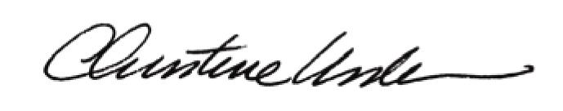

By:

Date of Meeting: December 21, 2015 Title: Historic Officer

